JAMIA HAMDARD

DEPARTMENT OF COMPUTER SCIENCE & ENGINEERING

School of Engineering Sciences & Technology



**MCA 107- Object Oriented Programming Lab**

**ASSIGNMENT FILE**

**SUBMITTED TO:** **Dr. Shahab Saquib Sohail Sir**

**SUBMITTED BY:** **Sukaina Inam Naqvi**

**Enrolment no: - JH23-PGP-02037**

MCA- 1st Year |  1st  Semester

**Question 6. Create a class in c++ to check whether a number is even or odd and is prime.**

**Code:-**

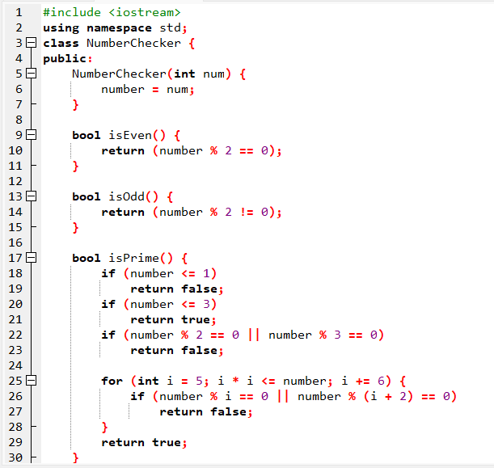

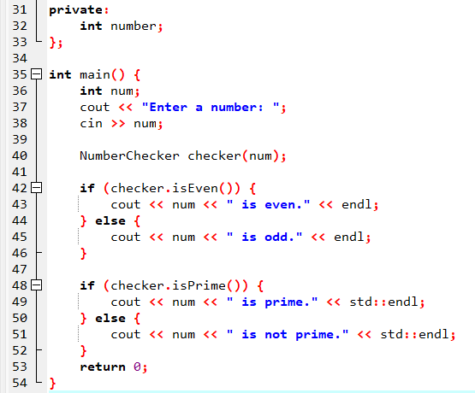

Output:-

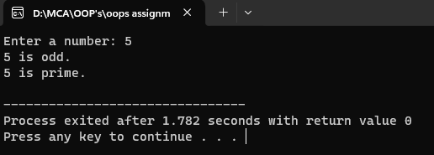 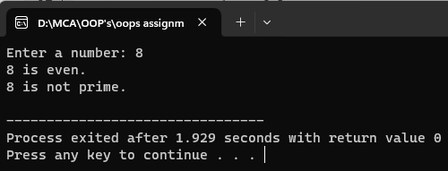

**Question 7.** **Create a student class with student_id, name, age & marks (multiple subjects).**

**Perform these operations:**

**1. Add a new student.**

**2. Display the information**

**Code:-**

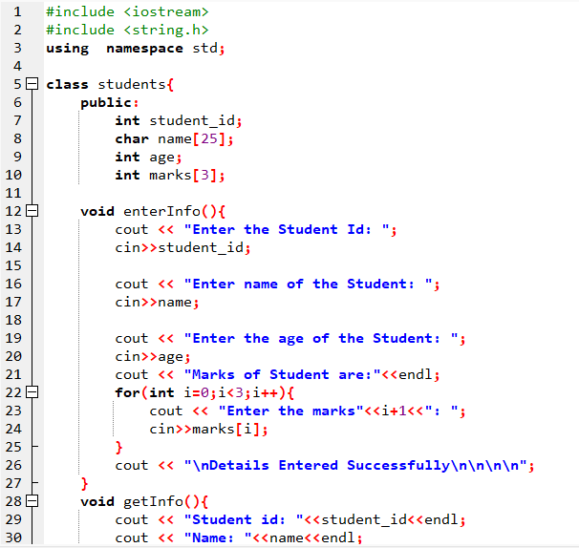

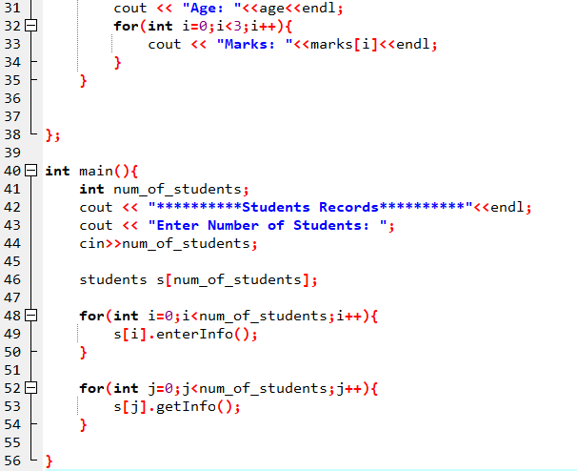

Output:-

 